import cv2 as cv

import matplotlib

import matplotlib.pyplot as plt

import numpy as np

from google.colab.patches import cv2_imshow

img=cv.imread('dhoni.jpg')

rows,cols=img.shape[:2]

src = np.float32([[0,0],[cols-1,0],[0,rows-1],[cols-1,rows-1]])

dst = np.float32([[0,0],[cols-1,0],[int(0.33*cols),rows-1],[int(0.66*cols),rows-1]])

perspective_matrix=cv.getPerspectiveTransform(src,dst)

out=cv.warpPerspective(img,perspective_matrix,(cols,rows))

cv2_imshow(img)

cv2_imshow(out)

#Affine transformation

pts1=np.float32([[50,50],[200,50],[50,200]])

pts2=np.float32([[10,100],[200,50],[100,250]])

M=cv.getAffineTransform(pts1,pts2)

img_afftran=cv.warpAffine(img,M,(cols,rows))

import math

#vertical wave

img_output=np.zeros(img_afftran.shape,dtype=img.dtype)

for i in range(rows):

  for j in range(cols):

    offset_x=int(25.0*math.sin(2*3.14*i/180))

    offset_y=0

    if j+offset_x < rows:

      img_output[i,j]=img_afftran[i,(j+offset_x)%cols]

    else:

      img_output[i,j]=0

cv2_imshow(img_output)

#horizontal wave

img_output=np.zeros(img_afftran.shape,dtype=img.dtype)

for i in range(rows):

  for j in range(cols):

    offset_x=0

    offset_y=int(25.0*math.cos(2*3.14*i/180))

    if j+offset_y < cols:

      img_output[i,j]=img_afftran[(i+offset_y)%rows,i]

    else:

      img_output[i,j]=0

cv2_imshow(img_output)

import cv2

img=cv2.imread('BW.jpg',0)

cv2_imshow(img)

kernel=np.ones((5,5),np.uint8)

erosion=cv2.erode(img,kernel,iterations=1)

cv2_imshow(erosion)

dilation=cv2.dilate(img,kernel,iterations=1)

cv2_imshow(dilation)

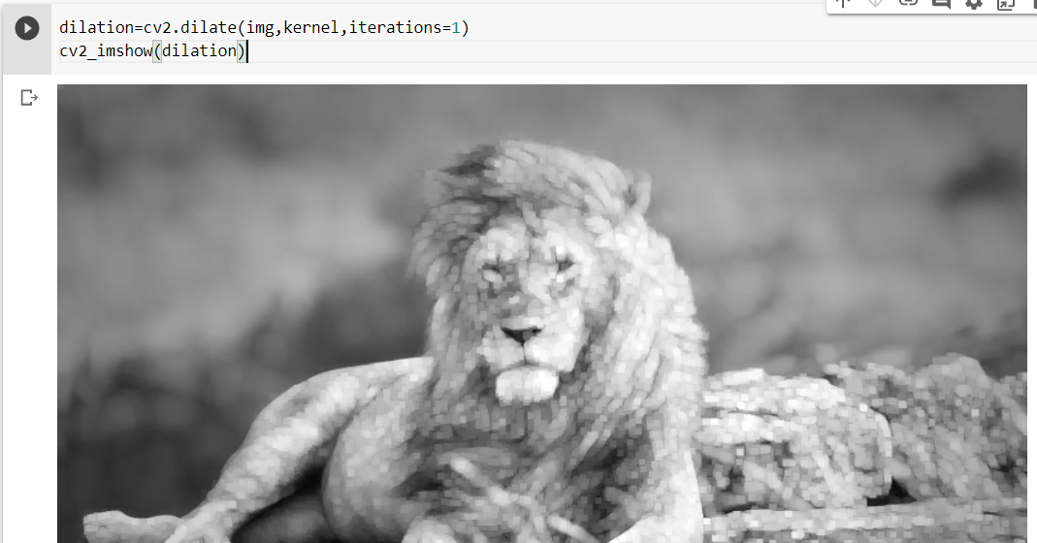

cv2_imshow(img)

kernel=np.ones((3,3),np.uint8)

img=cv.imread('A.webp')

cv2_imshow(img)

kernel=np.ones((3,3),np.uint8)

opening=cv2.morphologyEx(img,cv2.MORPH_OPEN,kernel)

cv2_imshow(opening)

closing=cv2.morphologyEx(img,cv2.MORPH_CLOSE,kernel)

cv2_imshow(closing)

import cv2

from google.colab.patches import cv2_imshow

# Read the original image

img = cv2.imread('dhoni.jpg')

# Display original image

cv2_imshow(img)

# Convert to graycsale

img_gray = cv2.cvtColor(img, cv2.COLOR_BGR2GRAY)

# Canny Edge Detection

edges = cv2.Canny(img_gray, 10,100) # Canny Edge Detection

# Display Canny Edge Detection Image

cv2_imshow(edges)

# find the contours in the edged image

contours, hierarchy = cv2.findContours(edges, cv2.RETR_EXTERNAL, cv2.CHAIN_APPROX_NONE)

#Find Number of Contours

print("Number of Contours is: "+str(len(contours)))

#draw yellow border around the contours

cv2.drawContours(img, contours, 0, (0, 230, 255), 6)

cv2.drawContours(img, contours, 2, (0, 230, 255), 6)

#show the image with Contours

cv2_imshow(img)

img = cv2.imread('CC.jfif')

# Display original image

cv2_imshow(img)

# Convert to graycsale

img_gray = cv2.cvtColor(img, cv2.COLOR_BGR2GRAY)

ret, thresh = cv2.threshold(img_gray, 255, 255, cv2.THRESH_BINARY_INV)

cv2_imshow(thresh)

contours, hierarchy = cv2.findContours(image=thresh, mode=cv2.RETR_TREE,

                                       method=cv2.CHAIN_APPROX_SIMPLE)

# draw all contours on the original image

cv2.drawContours(img, contours=contours, contourIdx=-1,

                 color=(0, 255, 0), thickness=2, lineType=cv2.LINE_AA)

cv2_imshow(img)

img = cv2.imread('CC.jfif',0)

img2=img.copy()

template=cv2.imread('dhoni.jpg',0)

cv2_imshow(template)

w,h = template.shape[::-1]

#ALl 6 methods for comparision in list

methods=['cv2.TM_CCOEFF','cv2.TM_CCOEFF_NORMED','cv2.TM_CCORR','cv2.TM_CCORR_NORMED','cv2.TM_SQDIFF','cv2.TM_SQDIFF_NORMED']

for meth in methods:

    img = img2.copy()

    method = eval(meth)

    # Apply template Matching

    res = cv2.matchTemplate(img,template,method)

    min_val, max_val, min_loc, max_loc = cv2.minMaxLoc(res)

    # If the method is TM_SQDIFF or TM_SQDIFF_NORMED, take minimum

    if method in [cv2.TM_SQDIFF, cv2.TM_SQDIFF_NORMED]:

        top_left = min_loc

    else:

        top_left = max_loc

    bottom_right = (top_left[0] + w, top_left[1] + h)

    cv2.rectangle(img,top_left, bottom_right, 255, 2)

    plt.subplot(121),plt.imshow(res,cmap = 'gray')

    plt.title('Matching Result'), plt.xticks([]), plt.yticks([])

    plt.subplot(122),plt.imshow(img,cmap = 'gray')

    plt.title('Detected Point'), plt.xticks([]), plt.yticks([])

    plt.suptitle(meth)

    print("  ")

    plt.show()



